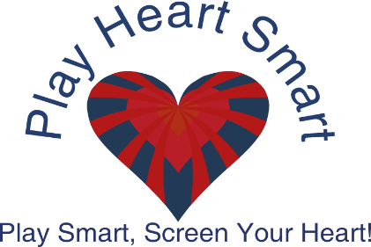

Child’s Name ___________________________________________ DOB__/___/___
Address_______________________ City____________ State_________ Zip_______
Contact # ( )______________________ Email:______________________________
Pediatrician_________________________ Child’s Race ________________________
School Name__________________________ Grade Level______________
Sport(s) being played_______________________________________________________
Yes No Has anyone in your family suddenly died under the age of 50? Including Sudden
Cardiac Arrest, Drowning, SIDS, Heart Disease or unexplained death while sleeping?
Yes No Student/athlete with previous cardiac diagnosis?
Yes No Palpitations (skipped heart beats)?
Yes No Experience unusual or extreme shortness of breath during or after exercise?
Yes No Dizziness or passing out without, during or before exercise?
Yes No Ever been diagnosed with a heart murmur?
Yes No Has your child ever had any previous testing on their heart?
Yes No Has your child ever been held out of sports due to a heart condition?
Has your child ever been diagnosed with any of the following?
High Blood Pressure High Cholesterol Diabetes Seizures Asthma
Does your child currently take any medications for the following?
ADD/ADHD Asthma Known heart conditions Seizures
Has your child had an annual visit with their pediatrician in the last two years? ______________
Does your child have a known heart condition? __________ If so, please explain below.
________________________________________________________________________.

GENERAL RELEASE FORM: PATIENT/PARENT SIGN BELOW
This screening is voluntary. I understand that the screening is not a complete Echocardiogram. I understand that I am responsible for my own health. Play Heart Smart is not a medical diagnostic establishment. The responsibility for any follow up examination to check abnormalities found during the partial echocardiogram lies solely with me and not with any participating organization, physician or other health care volunteer. I hereby release Play Heart Smart and all health care volunteers and physicians from all responsibility in connection with this screening.
PATIENT AUTHORIZATION FOR USE AND DISCLOSURE OF PROTECTED HEALTH INFORMATION (PHI): PATIENT/PARENT READ AND SIGN BELOW.
I understand that I have certain rights to limit uses and disclosures of my protected health information (PHI) under the regulations issued pursuant to the Health Insurance Portability and Accountability Act 1996 (HIPPA). I hereby authorize the disclosure of my PHI that is created during or as a result of my examination today at the partial Echo Screening to be shared with my PCP.
I understand that I may revoke this authorization at any time with a written request submitted to my physician or Play Heart Smart today (named below) as specified to the Notice of Privacy Practices that has been given to me, but that such revocation will have no effect on actions taken in reliance on this authorization prior to that time. Unless I revoke in writing, this authorization will have no expiration date.
I authorize the use and disclosure of my health information as described herein and acknowledge that I have received a copy of the applicable Notice of Privacy Practices and this signed form.
Please initial for MEDIA CONSENT:
_________ I hereby grant Play Heart Smart permission to use my minor’s photograph for
advertising, social media, illustration and web content . Furthermore, I understand no royalty, fee or other compensation shall become payable to me by reason of such use.

Parent/Guardian Print: ____________________________________
Parent/Guardian Signature: ___________________________________ Date:______________
(Patient, parent/Guardian of minor patient)

